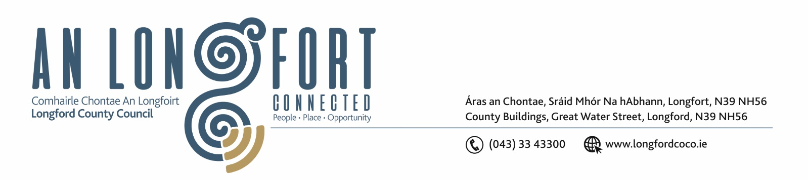

25th November 2019.

Chuig: Gach Ball don Chomhairle.

A Chomhairleoir,

You are requested to attend a Special Meeting of Longford County Council to be held in the Council Chamber, Aras an Chontae, Great Water Street, Longford on Monday, 2nd December 2019 at 5.00 p.m. to transact business, as set out on the Agenda hereunder.

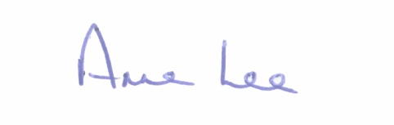
Mise le meas,

__________________
Anne Lee,
Meetings Administrator.

C L A R

1. Declaration of Interest by Members.

2. Consideration and adoption of Material Contravention of Longford County Development Plan 2015 – 2021 in accordance with Section 34(6) of the Planning and Development Act 2000 (as amended) in respect of housing development at Glebe, Cloondara, Co. Longford – details enclosed.

3. Consideration and adoption of Material Contravention of Longford County Development Plan 2015 – 2021 in accordance with Section 34(6) of the Planning and Development Act 2000 (as amended) in respect of housing development at Townparks, Newtownforbes, Co. Longford – details enclosed.

4. Appointment of Mr Sean Donohoe, nominee of Granard Traders Association, to replace Mr. Oliver Cassidy as a member of Longford Local Community Development Committee (LCDC).

5. Appointment of Mr. James Belton to represent the farming/agricultural community in Longford on the Longford Joint Policing Committee.



